**Miami-Dade County COVID-19 Hospital Impact Model for Epidemics (CHIME)**

The following epidemiological model was created for Miami-Dade County Fire Rescue by researchers at Florida International University. The model was created using the CHIME model created at the University of Pennsylvania (1). The report details two separate scenarios for social distancing, 37% and 50% respectively.

**Model Assumptions**

The estimated number of currently infected individuals is **17701**. This is based on current inputs for Hospitalizations (**320**), Hospitalization rate (**2%**), Region size (**2750000**), and Hospital market share (**100%**). An initial doubling time of **2.5** days and a recovery time of **14** days imply an R0 of **5.47** and daily growth rate of **31.95%**.**Mitigation**: A **30%** reduction in social contact after the onset of the outbreak reduces the doubling time to 3.8 days, implying an effective Rt of 3.83 and daily growth rate of 20.22%. Moderate social distancing corresponds to a **37%** reduction in social contact, and high social distancing corresponds to a **50%** reduction in social contact.

**Scenario 1: Moderate Social Distancing (37%)**

**New Admissions per day**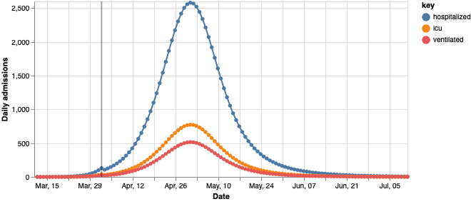

Hospitalized Admissions peaks at 2,582 on May 01

ICU Admissions peaks at 774 on May 01

Ventilated Admissions peaks at 516 on May 01

**Census (Total Burden per Date)**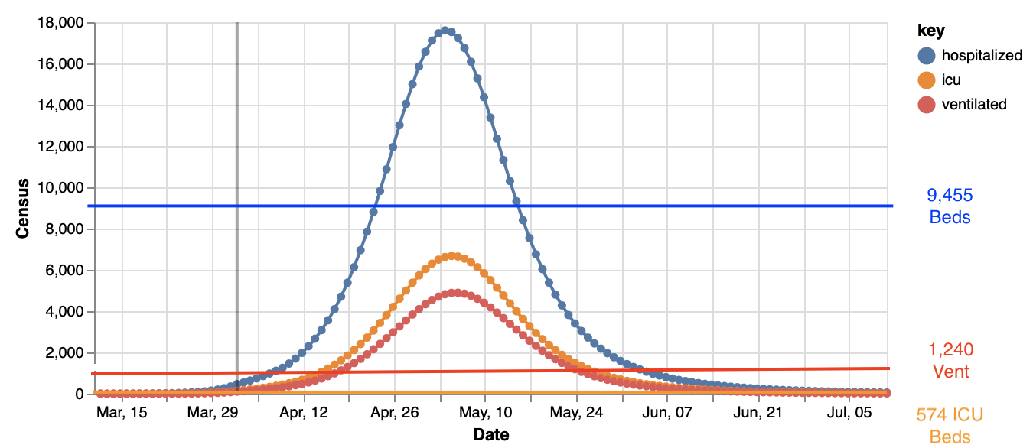

Hospitalized Census peaks at 17,602 on May 04

ICU Census peaks at 6,674 on May 05

Ventilated Census peaks at 4,892 on May 06

**Scenario 2: High Social Distancing (50%)**

**New Admissions per Day**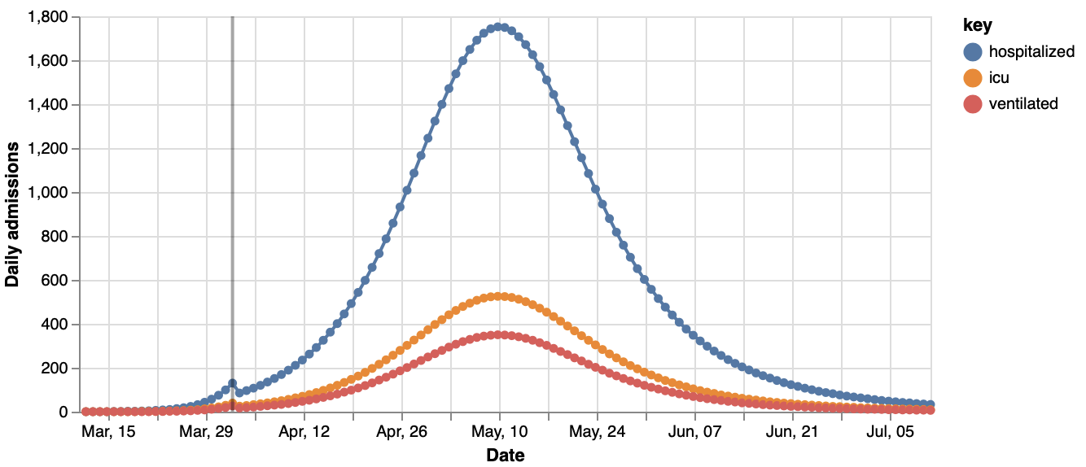

Hospitalized Admissions peaks at 1,752 on May 10

ICU Admissions peaks at 525 on May 10

Ventilated Admissions peaks at 350 on May 10

**Census (Total Burden per Date)**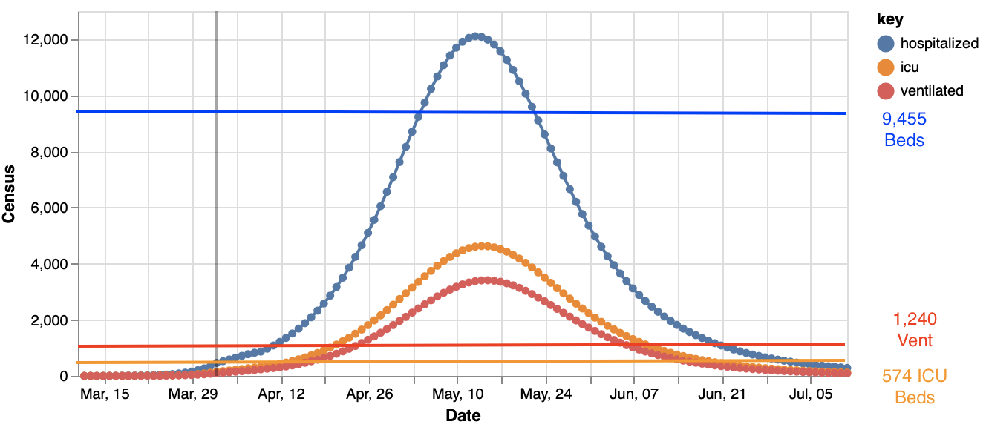

Hospitalized Census peaks at 12,103 on May 13

ICU Census peaks at 4,627 on May 14

Ventilated Census peaks at 3,409 on May 15

**Severity Comparison**

| Miami-Dade County COVID Hospital Expectation Estimates | | |
| --- | --- | --- |
|  | **37 % Social Distancing** | **50% Social Distancing** |
| Hospital Admit Peak Date | May 1st, 2020 | May 10th, 2020 |
| Hospital Admit Peak Amount | 2,651 | 1,752 |
| Hospitalized Peak Census Date | May 4th, 2020 | May 13th, 2020 |
| Hospitalized Peak Census | 17,819 | 12,103 |
| Total Hospital Admits by July 11th | 66,456 | 62,999 |
| ICU Admit Peak Date | May 1st, 2020 | May 10th, 2020 |
| ICU Admit Peak Amount Per Day | 784 | 525 |
| ICU Peak Census Date | May 5th, 2020 | May 14th, 2020 |
| ICU Peak Census | 6,754 | 4,627 |
| Total ICU Admit by July 11th | 19,936 | 18,899 |
| Ventilated Admit Peak Date | May 1st, 2020 | May 10th, 2020 |
| Ventilated Admit Peak Amount Per Day | 523 | 350 |
| Ventilated Census Peak Date | May 5th, 2020 | May 15th, 2020 |
| Ventilated Census Peak | 4,949 | 3,409 |
| Total Ventilated by July 11th | 13,291 | 12,599 |

**Executive Summary**

To this author’s knowledge, this is the first CHIME model applied to Miami-Dade County. Based on the magnitude of social distancing, the expected total number of hospitalizations predicted by **July 11th, 2020** ranges from **62,999** to **66,456** The peak of the epidemic in terms of daily hospitalizations, daily ICU cases, and daily ventilations varies by the amount of social distancing and ranges from **May 1st, 2020** to **May 10th, 2020.** A peak sometime near the first week of May corresponds exactly to the predicted peak resource usage for the State of Florida found using the Institute of Health Metrics and Evaluation’s Covid model (2) of May, 3rd. Peak Burden (census), i.e., the amount of hospitalizations occurring during the same time period ranges from **12,103 to 17,819.** Increasing social distancing from 37.5% social contact reduction to 50% social contract reduction reduces hospitalizations by approximately **32%**, and flattens the epidemic curve by approximately one-two weeks. For the ICU census peak, this value ranges from **4,627 to 6,754.** At 50% social contract reduction compared with 37%, this results in a **31.5%** reduction in ICU burden. Census peak for ventilation ranges from **3,409** to **4,949.** Similarly to hospitalization and ICU burden, through social distancing, peak ventilation census can be delayed by an average of 9 days. For ventilation census, this can be reduced by **30.3%** through social distancing. Overall, Miami Dade Count has an estimated 9.445 beds, 1,240 ventilators and 574 ICU beds. Assuming a 37% social distancing model in accordance with the average of Imperial College’s 33% estimate and University of Pennsylvania’s 42% estimate (3), **Miami-Dade County is short up to 8,374 beds, 6180 ICU beds and 4,375 ventilators**. This could pose a dire problem for public health in Miami-Dade County The next step for predicting Covid hospital impact in Miami-Dade County will be refining estimates of resource availability, resource need, and total mortality for Covid-19 in Miami-Dade County, and South Florida as a whole.

**Susceptible, Infected, and Recovered (SIR) Models**

This correspond with number of susceptible, infected, and recovered individuals in the hospital catchment region at any given moment

**Scenario 1: Moderate Social Distancing (37%)**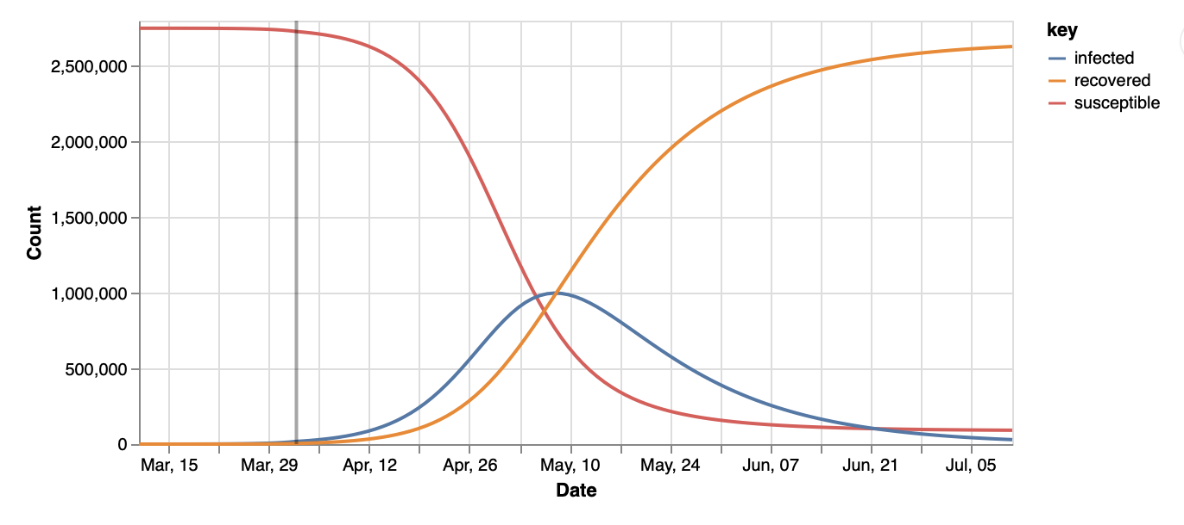

**Scenario 2: Large Social Distancing (50%)**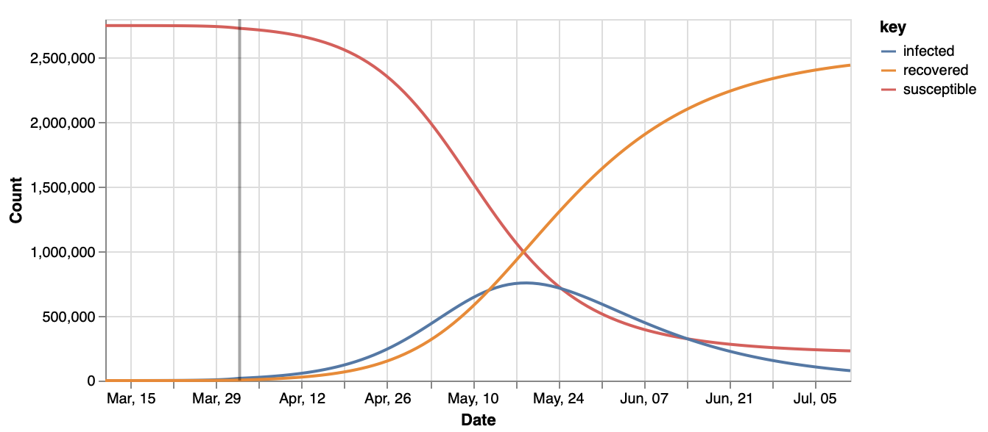

Graph shifts to right with increased social distancing from 20% to 60%

**References**

(1) University of Pennsylvania Covid Model. (2020, March 15). Retrieved April 2, 2020, from <https://code-for-philly.gitbook.io/chime/#quick-resources>

(2) IHME COVID-19 health service utilization forecasting team. Forecasting COVID-19 impact on hospital bed-days, ICU-days, ventilator days and deaths by US state in the next 4 months. MedRxiv. 26 March 2020. doi:10.1101/2020.03.27.20043752.

(3) Draugelis, M., & Hanish, A. (2020, March 18). CHIME comparison with Imperial College COVID-19 Publication. Retrieved April 2, 2020, from http://predictivehealthcare.pennmedicine.org/2020/03/18/compare-chime.html

**Appendix**

**IHME Florida Prediction on 4/02/2020**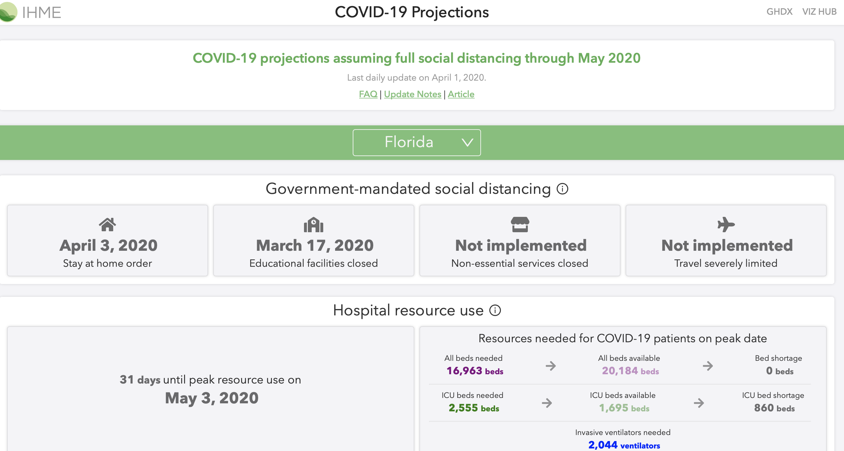

Peak Resource usage of May 3rd corresponds with our estimate of first week of May.

**Health Florida 4/02/2020**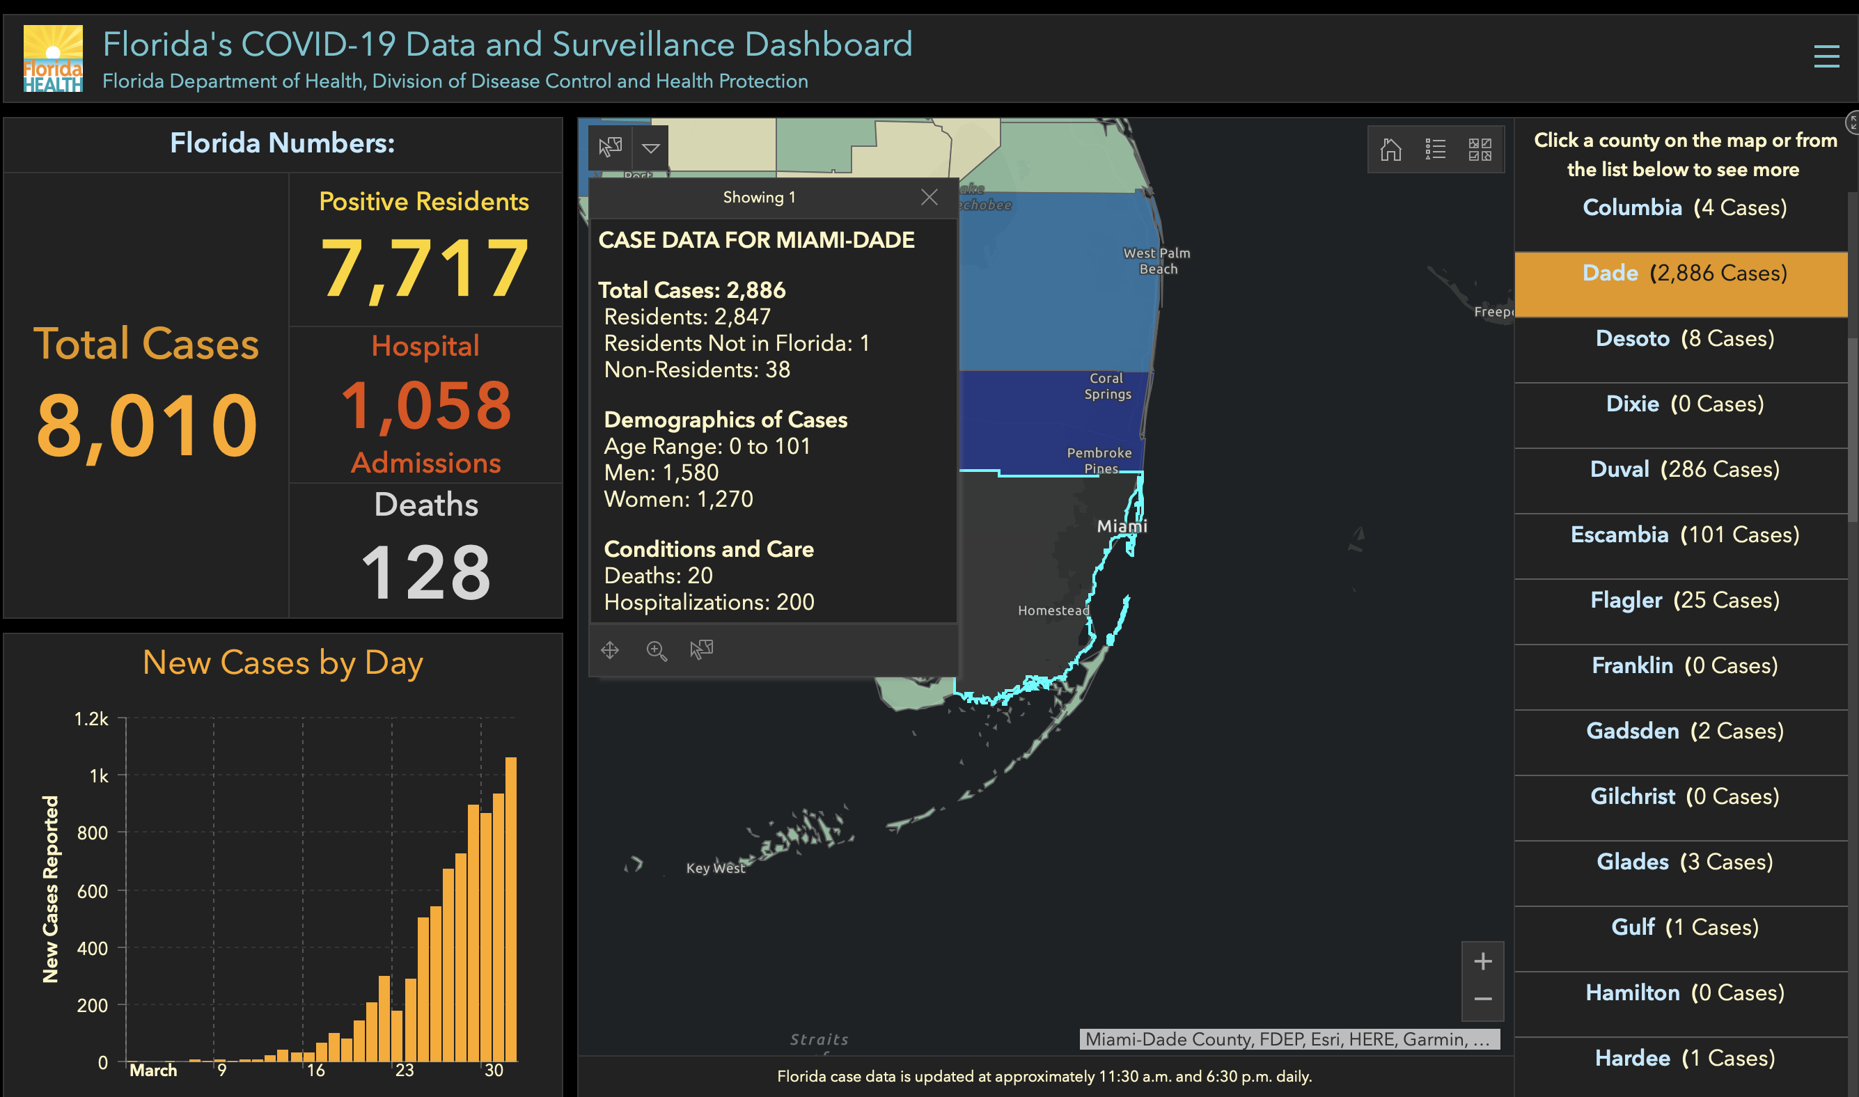

**CHIME Model Parameters**